Process Book

# Project Title: Ukraine Improvised Explosive Devices

# Project Team:

Online Studio 3 Group 3

Valérie Lavigne

[valelavi@gmail.com](mailto:valelavi@gmail.com)



Marius Panga

[marius.c.panga@gmail.com](mailto:marius.c.panga@gmail.com)



Jayaram Shivas Vadakumpuram

[shivasj@gmail.com](mailto:shivasj@gmail.com)



# Background and Motivation

Valérie works as a defence scientist for Defence R&D Canada and is the Canadian representative on the NATO Research Task Group IST-141 Exploratory Visual Analytics. Through her work, she was exposed to a dataset and presentation about the Ukraine Improvised Explosive Devices (IED) situation produced by the NATO Counter-IED Center of Excellence (NATO C-IED COE) which is an International Military Organization, multinationally manned and funded by contributions from 9 sponsoring NATO nations (<http://www.coec-ied.es/>). Figures 1 and 2 below show current static visualization employed by the C-IED COE to visualize this data.



*Figure 1: Map of Ukraine IED incidents in 2014-2015.*

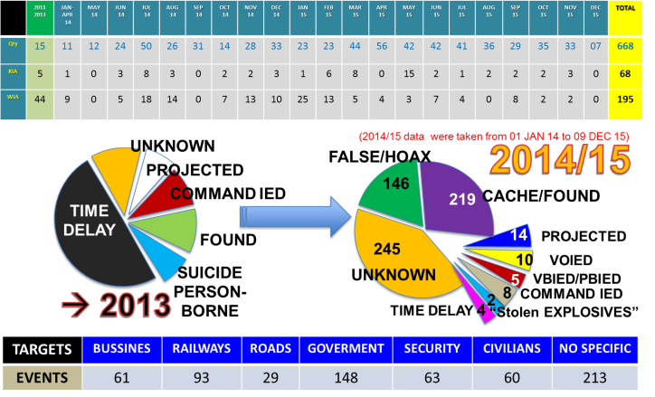

*Figure 2: Statistical data about Ukraine IED incidents in 2014-2015.*

Valérie, Marius and Shivas agreed that these visualizations could be improved upon using what they learned in the CS171 Visualization class. They decided to take the challenge of creating an interactive visualization for this data. The dataset is interesting because it contains many datatypes (quantitative, geographical, temporal, textual) and it can be augmented using additional data from the web. We intend to share the end result of our project with the NATO C-IED COE.

# Project Objectives and Goals

This project will allow the exploration of over 600 Improvised Explosive Devices incidents in Ukraine mostly over the past 2 years for the purpose of highlighting and better understanding the temporal, geographical and political patterns in that data. We will consider additional census data and election statistics to uncover potential regional patterns, as well as publicly available data about the existing conflict in Eastern Ukraine. We intend to employ interactive visualization to generate better insights about the Ukraine IED situation.

# Questions

By answering some or all of the questions below, our project aims to provide better insights into the Ukraine IDE situation:

* Is there a temporal pattern in the number of IED incidents?
* Where are the IED incidents located within Ukraine?
* How do the incidents relate to the conflict in Eastern Ukraine? Is there a relation between he number of incidents and the distance to the conflict zone and the political situation?
* Do the ratios of incidents remain stable over time between the different regions? Do the incidents seem to move from one region to another?
* How does the rate of IDE incidents relate to the total number of reported casualties and injuries?
* Do the different types of IEDs have interesting geo-temporal patterns?
* Is the number of incidents correlated with regional census data, more specifically:
  + Are there less or more incidents in Russian speaking regions?
  + Are there less or more incidents in poorer regions?
  + Is there a connections between the incidents and the political allegiance of the regions, according to the 2010 Presidential election data?
* Can we correlate any spikes or patterns in the data with political developments in the conflict (Crimea Annexation, agreed Ceasefire, Ukraine elections …)
* Is there any additional insight that can be obtained from the free-text incident description field in the main data source?

**Tasks**

Following is a list of tasks that could be identified in this early phase of the project. As the project progresses, this list will evolve with more tasks being added and some becoming obsolete or irrelevant.

* Data analysis: go over all the candidate data sources and selecting the bits of data that will be relevant to the project
* Data gathering: while our main data source is already in a structured format, the additional sources are not(news articles, PDF files, images). This step involves getting all the relevant data into a structured format (txt or cvs files)
* Data cleaning: make sure the data that has been identified as relevant is in a consistent format. Standardize the handling of incorrect or missing data, as well as any formatting issues
* Data filtering: based on the data analysis outcome, remove any data that is needed for the visualization
* Data model design: identify the JavaScript entities that will contain / reference the source data, and for each such entity define:
  + - Relationship with other data (how will it merge with other data)
    - Properties (name and data type) and methods
    - Default sort order

# Data

## Data Description

### NATO Ukraine IED Incidents Data

This is a NATO Unclassified IED events spreadsheet from the NATO C-IED COE. It contains 665 events, with 15 in 2001-2013, about 230 in 2014 and the rest in 2015. It contains the following column headers: Date, Type, KIA (Killed in Action), WIA (Wounded in Action), City, Region, Country, Details, Group, Remarks. There are missing values in the dataset. Table 1 below provides a sample of the data for December 2015.

*Table 1: Sample of the Ukraine IED incidents data for December 2015.*

|  |  |  |  |  |  |  |  |  |  |
| --- | --- | --- | --- | --- | --- | --- | --- | --- | --- |
| **DATE** | **TYPE** | **KIA** | **WIA** | **CITY** | **REGION** | **COUNTRY** | **DETAILS** | **GROUP** | **REMARKS** |
| 2015 DEC 09 | CACHE/FOUND | 0 | 0 | Kramatorsk | DONETSK | UKRAINE | IEDs were found and disposed by Combat Engineers |  | TBC if they were just landmines |
| 2015 DEC 09 | UNKNOWN | 0 | 0 | Kharkiv | KHARKIV | UKRAINE | An IED was blown up in front of a ROSHEN shop |  | Shopping Center |
| 2015 DEC 08 | UNKNOWN | 0 | 0 | Kiev | KIEV | UKRAINE | A device was detonated against a restaurant (L'Kafa) |  | Boulevard Lesi Ukrainian |
| 2015 DEC 07 | HOAX/FALSE | 0 | 0 | Ivano-Frankivsk | IVANO-FRANKIVSK | UKRAINE | Call reporting IED - First Responders action - no explosive |  | Central Metro/bus station |
| 2015 DEC 02 | CACHE/FOUND | 0 | 0 | Krasnoarmiisk | DONETSK | UKRAINE | An IED was found and disposed by EOD |  |  |
| 2015 DEC 02 | CACHE/FOUND | 0 | 0 | Avdeevka | DONETSK | UKRAINE | A cache with 3 IEDs with TNT was found and cleared |  | Inside an abandoned house |
| 2015 DEC 02 | UNKNOWN | 0 | 0 | Uzhgorod | ZAKARPATS'KA | UKRAINE | An IED was detonated against a store in Franko Street |  |  |

### Ukraine Map Data

We will a geojson/topojson data about the various regions of Ukraine as we expect some of this information might be displayed on a map. We have found two potentially suitable Ukraine map data files.

### Ukraine Census Data

We also want to include various statistics about Ukraine to see if we can find patterns between the IED events and these statistics. So far, we found the population of each district, as per Jan 2013 (<http://ukrstat.gov.ua/operativ/operativ2013/ds/kn/kn_e/kn0113_e.html>), as well as the monthly wages by region from 1995 to 2015 (<http://ukrstat.gov.ua/operativ/operativ2006/gdn/prc_rik/prc_rik_e/dszpR_e2006.htm>).

We are considering using the output of the 2011 Ukraine census as another data source for this project (<http://database.ukrcensus.gov.ua/MULT/Database/Census/databasetree_en.asp>). We could extract more dimensions like education, sources of livelihood and especially native language. The data seems to be at region level, similar in grain to the NATO data. Also, derived from the census, we have the number of Russians in Ukraine, by province, in 2001: (<https://en.wikipedia.org/wiki/Russians_in_Ukraine>).

**Ukraine 2010 Presidential Elections Data**

Since the Ukraine started with the removal from power of the previously elected president Viktor Yanukovych, we wish to provide the user with an underlying political map, based on the 2010 presidential elections. The source data has the same geographical grain as our main data set (region). Source: <https://commons.wikimedia.org/wiki/User:DemocracyATwork>

**Ukraine Conflict Timeline**

As we believe the IED incidents are closely related to the Ukraine conflict, we will use

this timeline of the conflict’s major events to try to explain any spikes or patterns of the number of IED incidents as well as enhance the overall narrative. Source: <http://www.bbc.co.uk/news/world-middle-east-26248275>

**Ukraine Conflict Casualties and Injuries Data**

We will consider using this UN report in order to provide additional key facts about the Ukraine conflict (number of casualties and injuries by month), as well as to try to establish a relation between the number of casualties and injuries and the number if IED explosions. Source: <http://www.ohchr.org/Documents/Countries/UA/12thOHCHRreportUkraine.pdf>

# Visualization Design

## Inspirations

### Map and Timeline

<http://www.bloomberg.com/graphics/2015-atm-bombers/>

This visualization shows the geo-temporal aspects of U.K. ATM bombing incidents. The webpage itself has a very strong storytelling design.

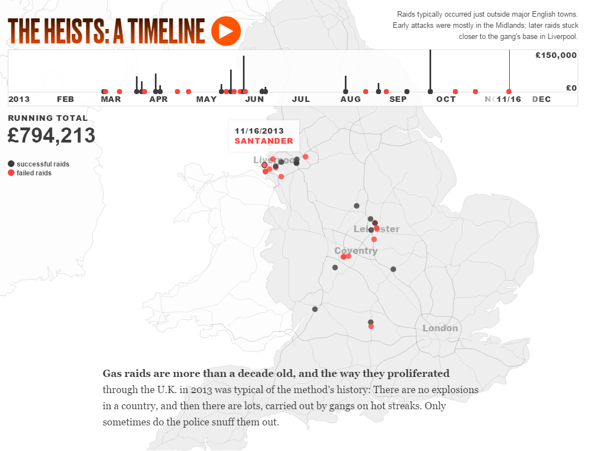

### Linked Views

<http://www.kms-world.com/solutions/industries/oil-gas>

This visualization links multiple data aspects together with an interesting use of colors.

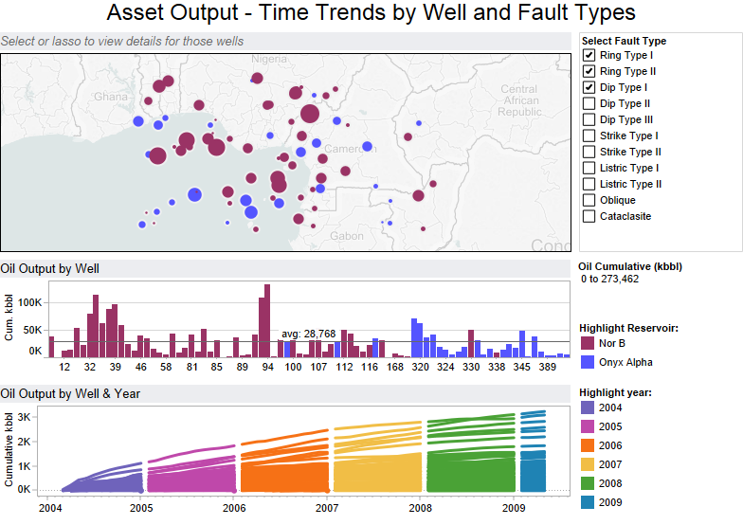

**Interactive storytelling**

<http://vis.stanford.edu/files/2010-Narrative-InfoVis.pdf>

This visual does a great job at guiding the reader through the visualization and highlighting key events, while at the same time introducing more context and bridging the gap between story and interactive visual.

Afghanistan: Behind the Front End. Financial Times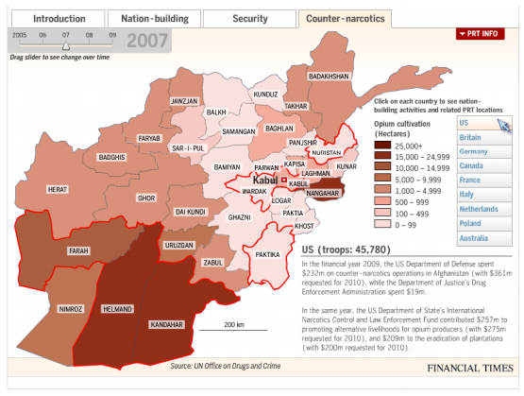

## Design Evolution

### Sketches 1

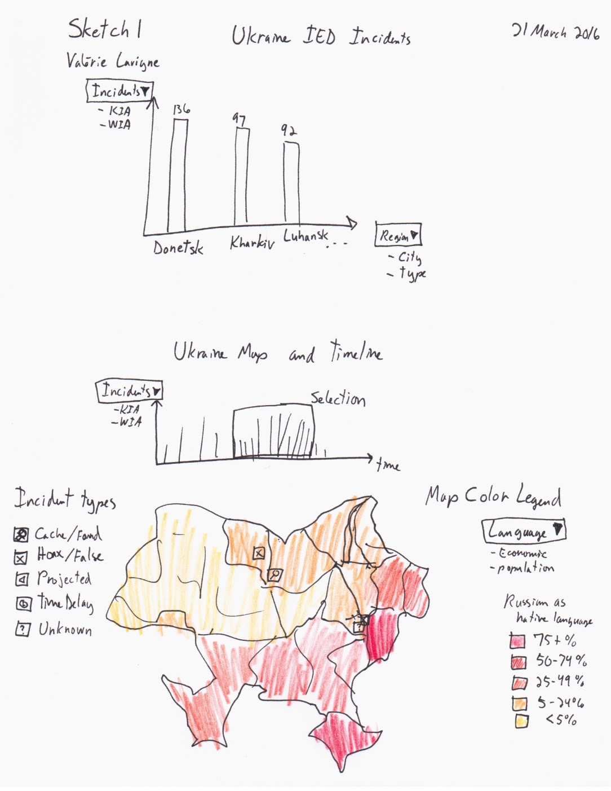

### Sketches 2

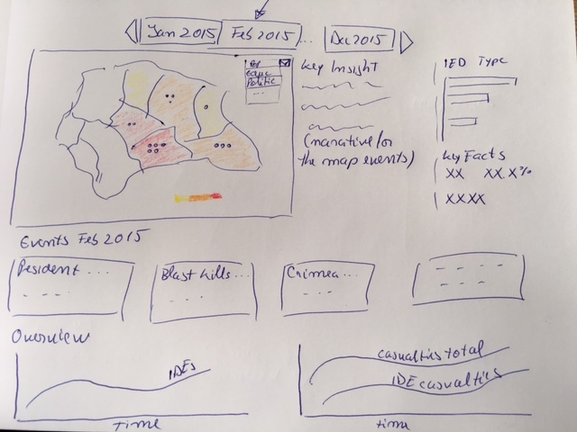

### Sketch 3

(insert sketches)

## Exploratory Data Analysis (coming soon, using Tableau)